About BES Magnet
Han Shiwen
Dec. 7, 2000
I. Introduction
Whether we can construct a new drift chamber to increase solid angle of the drift chamber when the door of the BES detector push out a certain distance. The new drift chamber must keep 4000 GS magnetic field strength at the center of drift chamber and uniformity of magnetic field in the region of the drift chamber is better then 5%. The problem arises, What distance should the door of detector push out and in how big region can the magnetic field meet the above requirement if the door pushes out a certain distance? In this report I introduce the magnetic field distribution when the door of the BES detector push out a certain distance.
II. The magnetic field distribution for present solenoid magnet
The magnetic structure of the BES detector, which is used for the field calculation, is shown in Fig. 1. For the reason of simplicity the geometry is assumed completely axisymmetric, which is a justifiable assumption for our case, only a quadrant is shown here. The magnetic field strength at the center of the BES detector is 4000 Gs. The field distribution inside the solenoid is shown in Fig. 2. The field uniformity inside the solenoid at 4000 Gs is shown in Fig. 3 (the deviation $Δ$Bz of the axial field component from the central field Bz(0) is shown in percent). Inside the region of the tracking chamber, the deviation are from +1% to -1% (corresponding to Z=0 -100 cm , R≤ 100 cm).
III. The magnetic field distribution for moving over the door a certain distance
When the door of the BES detector is pushed out 17.5 cm, corresponding magnetic structure of the BES detector used for the field calculation is shown in Fig. 4. The field strength at the center of the BES detector is 4000 Gs at current of 3250 Amp. The field distribution inside the solenoid is shown in Fig. 5. The axial field component is higher near the central winding of the coil and gradually decreasing toward the opening of the door. Fig. 6 presents the field uniformity inside the solenoid. It is normalized by the value of BZ(0) and given in percent. Uniformity of magnetic field is varying from 1.3% to-2.2% in the region of Z=0-100 cm, R≤100 cm. The maximum varying is 3.5%. Uniformity of magnetic field is varying from 1.3% to -3.3% of Z=0-117.5 cm, R≤100 cm. The maximum varying is 4.6%. Uniformity of magnetic field can improve more then 0.5% after adjusting some dimensions of magnetic circuit. So Uniformity of magnetic field can reach up to 4% in this region.

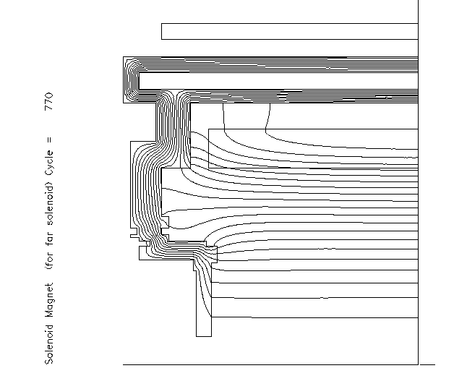
Fig.1 The BES solenoid magnet
Fig.2 Field distribution for present solenoid magnet
Fig.3 Field uniformity for present solenoid magnet
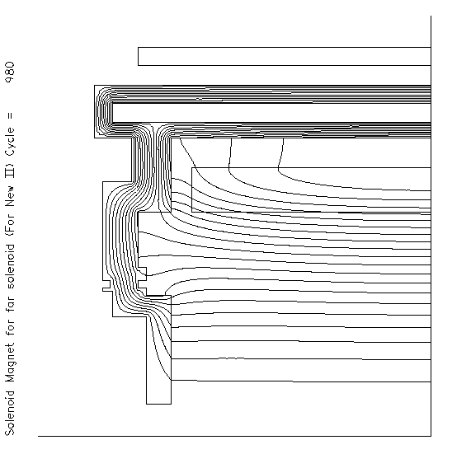
Fig.4 Moving over the door a certain distance

The bigger the distance of the door’ pushing out is, the bigger the current to produce 4000 GS at the center of the BES detector should be and the more ununiform the magnetic field becomes.
When the door of the BES detector is pushed out 20 cm, the field strength of 4000 GS at the center of the BES detector needs current of 3260 Amp. The field distribution inside the solenoid is shown in Fig. 7, Fig. 8 presents the field Uniformity inside the solenoid. Uniformity of magnetic field is varying from 1.5% to -2.3% in the region of Z=0-100 cm. Uniformity of magnetic field is varying from 1.5% to -4.0% in the region of Z=0-120 cm, the maximum varying is 5.5%. If the door is moved over the maximum possible position, the current of 3370 Amp can get field strength of 4000 GS at the center of the BES detector. Fig. 9 and Fig. 10 show the magnetic field distribution and field uniformity inside the solenoid. Uniformity of magnetic field is varying from 2.7% to -5.3% in the region of Z=0-100 cm, R≤100 cm. The maximum varying is 8.0%. Uniformity of magnetic field is varying from 2.7% to -7.3% in the region of Z=0-120 cm, R≤100 cm. The maximum varying is 10%.
Fig. 11 presents BZ distribution along Z axial for moving over the door different distance.
Fig.5 Field distribution for I=3250 Amp.

Fig.6 Field uniformity for I=3250 Amp.

Fig.7 Field distribution for I=3260 Amp.
Fig.8 Field Uniformity for I=3260 Amp.
Fig.9 Field distribution for 3370 Amp.
Fig.10 Field uniformity for 3370 Amp.
Fig.11 Bz distribution along Z axis

