Study of the Threshold Čerenkov Counter
in Test Beam

Cui Xiangzong
( Test Beam Group )
Nov. , 29, 2000

- why the usage of the Čerenkov counter in the test beam is necessary?

What problem for identifying particles by Time of Flight (TOF) method in the momentum range from 200MeV/c to 1GeV/c has been appeared?

  - Time resolution of the TOF method
Since the width of the beam is 2.5ns, so if the difference of the time of flight of two particles is less than 2.5ns, the particles will not be identified.
When the momentum of the particles is p>100MeV/c, the value (m_{e}/p)² of the electron is almost equal to zero, so the relationship between the Δt
$p=\frac{m_{π}}{\sqrt{{\left(\frac{Δt⋅c}{L}+1\right)}^{2}−1}} \left(1\text{.}1\right)$(difference of the TOF of electron and pion) and p ( the momentum of the particles) can be represented as

here L≤10m is distance between two scintillation counters, the mass of the pion m_{π}=140MeV/c² and the c=3×10⁸m/s is speed of the light in the vacuum, so the p=355MeV/c is obtained asΔt=2.5ns by relation (1.1).
The conclusion is, that the electron and the pion can not be identified when their momentum is great than 355MeV/c.

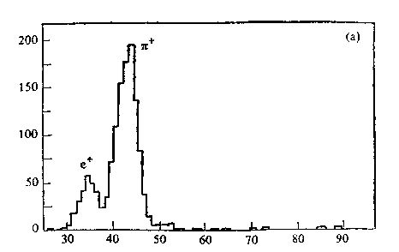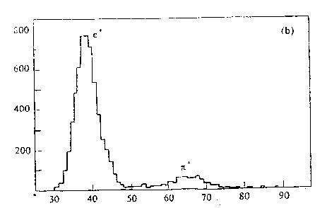
TDC TDC
Fig. 1.1 Spectrum of the TOF of the Fig. 1.2 Spectrum of the TOF of the
particles with p=371MeV/c. particles with p=210MeV/c.
As shown in the spectrums of TOF of e⁺ and π⁺ (Fig. 1.1 and Fig. 1.2) taken from experimental measurement (momentums of the particles are respectively 210MeV/c and 371MeV/c in Figures)^{[1]}, if the momentum is greater than 371MeV/c, the identification of e⁺ and π⁺ is rather poor.

  - Miss-identification of the particles must be not too high
The kind of particles in the test beam should be unitary, more miss-identification of the particles by TOF way as that in BES will be never allowed.
Based on above reasons, the application of a Čerenkov counter, which used for selecting the particles in the test beam, has significance.
A beam of the e and πmixture will be generated, so the threshold Čerenkov counter may be used to select the electrons, or inverse, to reject electrons by anti-coincidence to get the pions.

- The already existed Čerenkov counter in the laboratory is not appropriate for our use.

2.1 The existed Čerenkov counter was designed by using Isobutan(C₄H₁₀)
as the radiator for generating Čerenkov light (the refractive index is n=1.00124), so the length of the radiator is only 60cm^{[2]}. Since such gas is not security and too expensive, so it is not appropriate for using.
In practice, the gas CO₂ under higher pressure was used to measure the electrons of the test beam, the pressure is≥4atm, in this way, the counter windows were made by stainless still with few mm thickness, which bring about a serious scattering of the electrons in the radiator. But if some kind of gases operated under the normal pressure (1atm or little more) is taken as the radiator, for example usually used gases H₂、He、N₂、CH₄、CO₂ and so on, then the length of the radiator must be long enough to provide higher detection efficiency.

2.2 The measurement of the pion beam has shown, that the counting efficiency of the electrons by Čerenkov counter is lower ( ≤97% ).From the measured spectrum of the time of flight it can be seen, that the rejection of electrons in the beam was not satisfactory shown in Fig. 3-1^{[1]}.
Because of above mentioned reasons, to design a new threshold
Čerenkov counter will be necessary.
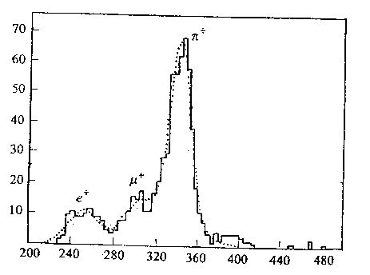
TDC
Fig. 2.1 Rejection of the electrons using anti-coincidence with the č counter.

- Design of the threshold Čerenkov counter to be used for selecting electrons.

  - The choice of the Čerenkov radiator
For the electron and muon with momentum to be about 1.5GeV/c, the refractive indexes, n, which is needed for generating Čerenkov radiation, are respectively n₁≥1/β_{μ}= 1.00245 for the muon and n₂≥1/β_{e}= 1.000000058 for the electron. So if the electrons can be selected by Čerenkov counter, then the region of the n, 1.000000058 < n < 1.00245, should be taken for the radiator. Only gas can be used as the Čerenkov radiator, and the following characters of the radiator will be required:
3.1.1.Transparency of the light is better. The absorption of the light, especially of the light with short wavelength, should be less.
3.1.2. The ionization loss of the particle energy, which decelerates the velocity of the particle and bring the change of the Čerenkov angle, has to be as small as possible.
3.1.3. There is no radiation of the scintillation, or scintillation emission is as little as possible.
3.1.4. The optics dispersion in the radiator is not big.
3.1.5. The scattering of the electrons by the radiator is not serious.
These requirements can be satisfied for following gases:
He, Ne, H₂, N₂, CH₄, CO₂ ,SF₆ and so on^{[3]}.
To make comparison between these gases, the CO₂ both is cheaper and is secure, and the refractive index are in the range of n = 1.000421( λ=6000Å) ～ n = 1.000491(λ= Å)(under the condition of 1atm and 20⁰c), which satisfies the requirement of n₂ < n < n₁ too. Although for the gas CH₄, the optics dispersion and the scattering of the particle are both smaller than that of the CO₂, and the refractive index of CH₄ is almost same with that of the CO₂. But gas CH₄ is friable, so we do not like to use it.
To take CO₂ as a radiator, the threshold velocity of the particle for generating Čerenkov radiation is calculated as follows.
$\text{cos}θ=\frac{v_{ν}}{v_{p}}=\frac{c/n}{v_{p}}=\frac{1}{nβ} (3\text{.}1)$The angle of the Čerenkov radiation can be represented as^{[3]}
$β=\frac{1}{n}=\frac{1}{1\text{.}\text{00041}}=0\text{.}\text{99959} (3\text{.}2)$The cosθ<1 is required for generating Čerenkov radiation. The critical velocity ( threshold velocity ) can be determined upon cosθ=1, that means

On this requirement, in order to generate the Čerenkov radiation, the momentum should be p > 17.8MeV/c for the electron, and p > 3.67GeV/c for the muon, as well p > 4.9GeV/c for the pion.
Maximum momentum of the beam particles is 1.5GeV/c in our situation, so the muon and the pion can not radiate Čerenkov light in the gas CO₂ operated under standard condition.

  - Maximum Čerenkov angle

$\text{cos}θ=\frac{1}{nβ} \left(3\text{.}3\right)$ On the equation
$n=A+\frac{B}{λ^{2}}+\frac{C}{λ^{4}} (3\text{.}4)$the maximum value of θcan be calculated. The β= 0.999999942 when the momentum to be 1.5GeV/c of the electron is taken. According to Kosi experience formula^{[4]}
$n=1\text{.}\text{000414}+\frac{2\text{.}5}{λ^{2}} (3\text{.}5)$to take first and second items, the refractive index of CO₂ can be written as
here the unit of λis nm, the maximum value of n is 1.000491 at theλ= 180nm,so the maximum Čerenkov angle will be
θ≌ 31mr = 1.8⁰
$θ<θ_{μ}=\sqrt{\frac{m_{μ}^{2}−m_{e}^{2}}{p^{2}}}=\text{70}\text{mr}$This angle is far small than that generated by muon, that is

3.3 Determination of the radiator length

On the theory of Tamm-Frank^{[5]}, the number of photons of Čerenkov radiation can be represented as
$\frac{{\text{dN}}_{ν}}{\text{dL}}=2\text{πα}z^{2}\left(1−\frac{1}{n{\left(λ\right)}^{2}β^{2}}\right)/λ^{2}dλ (3\text{.}6)$
If consider the n as a constant, then dN_{υ}/dL is proportional to 1/λ², this means most of the Čerenkov light appears in the short wavelength. To integrate the relationship (3.6), the number of the photons of Čerenkov light may be obtained:
$N_{ν}=2\text{πα}z^{2}L\left(\frac{1}{λ_{2}}−\frac{1}{λ_{1}}\right){\text{sin}}^{2}θ \left(3\text{.}7\right)$
Substitute λ₁= 600nm andλ₂= 200nm into the relation(3.7),then
N_{ν}= 1529×L×sin²θ (3.8)
Assuming the collective efficiency of the light by the optical system to be 70%, and the photocathode of the photomultiplier is sensitive to the ultraviolet ( for example XP2020Q tube ), then the quantum efficiency will be
$Q=N_{K}\frac{\text{12}\text{.}4}{λ}\text{100}\left(\text{\%}\right)≃\text{25}\text{\%}$
here N_{K} = 80mA/W and λ= 400nm were taken.
In this way, the number of photoelectrons per cm can be written as
N_{e} = 267×L×sin²θ= A×L×sin²θ (3.9)
$ε=1−e^{−N_{e}} \left(3\text{.}\text{10}\right)$Where A is a parameter which characterizes the collective efficiency of Čerenkov light and the quantum efficiency of the photomultiplier, the unit of A is photoelectrons per cm. The experiments have shown^{[6]}, that A = 50～60 for photomultiplier with general glass, and A = 100～150 for the photomultiplier with Sb-K-Cs photocathode and quartz window. We take A=100 in this design. The N_{e} in the relation (3.9) should be determined by detection efficiency of the Čerenkov counter, that is

where εis detective efficiency of the Čerenkov counter. If the ε≥99.99% is required, then N_{e}≥9.2 has to be detected by Čerenkov counter. We take the N_{e} = 10 and Čerenkov angle θ= 1.7⁰ which responds to Čerenkov light with wavelength λ= 400nm. In this case, the length of the radiator is obtained to be

$L=\frac{N_{e}}{A{\text{sin}}^{2}θ}=\frac{\text{10}}{\text{100}×{\text{sin}}^{2}1\text{.}7^{0}}=\text{119}\text{cm} \left(3\text{.}\text{11}\right)$
which entirely satisfactory the requirement of L ≥ (N_{e}/A)[p²/(m_{μ}²－m_{e}²)].
The radiator length L = 120cm is taken. If longer radiator is taken, that means to increase the value of N_{e}, then the effect of the fluctuation of the photoelectrons for the particles detection may be deduced, but length should not be too long, otherwise the absorption and scattering, as well the δ-electrons emission for the particles will be increased.

  - Refractive mirror, and determination of the distance from photocathode
to the reflective mirror.

For saving money, the existed spherical mirror will be used for collecting Čerenkov light. The geometric parameters of the mirror are the focal length to be f = 26cm and the diameter to be D = 15cm. According to the radius of the measured beam, b = 1.5cm, as well the value of L and maximum θ, the D = 2×(b+Lθ)= 10.4cm is obtained, which is enough big for our use. The materials for making mirror is borosilicate glass ( pyrex ). The thickness of the mirror at the center was reduced up to 2mm to diminish the absorption and scattering of the particles. The surface of the mirror is coated by Al especially for reflecting the light at ultraviolet wavelength, and a protective interference layer of λ/2 thickness of MgF₂ at 350nm is coated on the Al^{[6]}.
Calculation of the distance from focusing plane to the mirror has been made.If the mirror is perpendicular relative to the central axis of the Čerenkov counter as shown in Fig. 3.1, then the distance from image plane to the center of the mirror can be calculated to be
h = R － f × cosθ (3.12)
where R = 2f is the curvature radius. And the image radius is obtained as
r = f × tanθ=f ×θ (3.13)
where the Čerenkov angle θis very small.
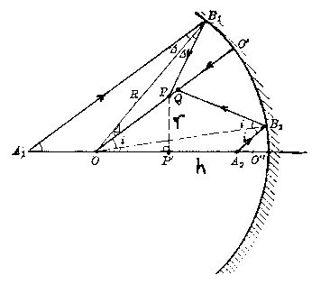
Fig. 3.1 Focusing and imagery of the č light by the vertical spherical mirror.

The mirror should be inclined relative to vertical line, so as to make the reflective light is focused at vicinity of the wall ofČerenkov counter. Assuming the inclined angle of the mirror is represented by α, then following equations can be deducedusing the rule of geometric optics imagery^{[7]}:

h = R cos(α) － f cos(2α±θ) (3.14)

where ±θare Čerenkov angles which respectively respond to different side on the central axis. And the imagery radius is yet calculated to be
r = f [sin(2α±θ) － 2sin(α)] (3.15)
These formulas just same as the functions(3.12) and (3.13) whenα=0.
For convenience of the manufacture and so on, theα= 11⁰ will be taken
In this way, the angle between central line of the photomultiplier and the central axis of the Čerenkov counter should be 22⁰ (i.e. 2α). On this situation, the position of the imagery plane is h = 26.6～27.3cm. In order to get more better focusing, the h = 27～28cm to be taken will be suitable.
$Δr=−\frac{1}{8}{\left(D/f\right)}^{3}+{\left(D/f\right)}^{2}θ \left(3\text{.}\text{16}\right)$The imagery radius r = 0.7～1.04cm has been obtained from the formula (3.15). The radius of the photomultiplier is 2cm, so the image can be entirely accepted by the photocathode. The total radiation spread Δr of the ring image can be determined by the spherical and coma aberrations which, up to third order, are given by^{[3]}

the meaning of every parameter in this formula are already mentioned above. Substitute values of the D、f and θ, the Δr ≌ 0.02cm is obtained, so the influence of the aberration may be negligible.
The photomultiplier is isolated from the counter volume by a quartz glass window. This window has no absorption lines in the ultraviolet. The surface of the glass is coated by MgF₂ layer of λ/4 thickness at 350nm for increasing the transparence of the Čerenkov light. The optical contact between the quartz window and the photocathode of the photomultiplier is made with silicon grease^{[6]}.

  - Based on above analysis and using existed materials, the Čerenkov counter cylinder of stainless steel with 130cm total length and 20.9cm inner diameter will be used for making the body of the Čerenkov counter. In order to reduce the energy loss and scattering of the electrons in the Čerenkov counter, the blacked Mylar windows with 0.2～0.4mm thickness will be used at the ends of the counter.
The schematic diagram of the designed threshold Čerenkov counter is shown in Fig. 3.2.
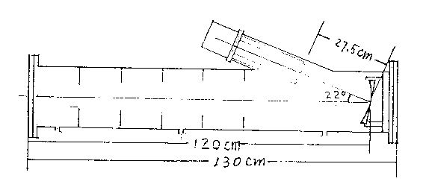
Fig. 3.2 Schematic diagram of the čereckov counter.

  - System for the registering Čerenkov signals.

Because the Čerenkov light has very weak intensity, so for obtaining the good ratio of the signal and noise, the higher sensitivity and the lower noise of the photomultiplier and electronics must be required. The single photoelectron should be registered in such system. The photomultiplier of the type XP2020Q and the constant fraction discriminator will be used.

  - The other characters of the designed Čerenkov counter.

3.7.1 Velocity resolution
The velocity resolution of the counter, which is 4.2×10^{－4}, can be reached as shown in equation^{[3]}:

$\frac{Δβ}{β}=\frac{N_{e}}{2\text{AL}}=4\text{.}2×{\text{10}}^{−4}$ The relative difference of the velocities between the μand e with momentum p = 1.5GeV/c, Δβ/β,is equal to 2.5×10^{－3}, so there is no problem for identifying theμand e.
Our Čerenkov counter is used only for the electrons selection, and is not for analyzing the velocity. Both the muon and the pion can not generate the Čerenkov radiation in the gas CO₂ which is operated under the pressure to be less than 1.2～1.5atm, so if the energy range of the beam particles is no over 1.5GeV/c, then we do not need to pay attention to the velocity resolution in our design of Čerenkov counter.

3.7.2 δ- electrons influence
$N\left(E_{δ}/E_{0}\right)≃0\text{.}\text{154}\frac{Z}{A}\frac{ρx}{β}\frac{1}{E_{0}}$When the momentum of the pion is ≥ 600MeV/c, then theδ- electrons emitted by pion are able to radiate the Čerenkov light which may be registered by the photodetector. Using following formulas^{[8]}
and
${\text{cos}}^{2}θ_{δ}≈E_{δ}/E_{m}$
to make calculation. If substitute the E₀ = 17.8MeV and the E_{m} maximum transmission of energy of the particle into the formulas, then the probability generatingδ- electrons by pion, which can be of the registered, is about 0.1%.

3.7.3 The inner surface of the Čerenkov cylinder has a black layer, which absorbs background radiation due to gas scintillation and Čerenkov light ofδ- electrons. Six diaphragms will be installed inside the cylinder for more effective absorption of the background radiation.
The optical dispersion, multiscattering and the energy loss by ionization, as well their influence on changing Čerenkov angle, have been estimated. These effects will result in the error of Δβ/βto be ～10⁻⁵.

3.7.4 Estimation of the cost

The total cost for building the Čerenkov counter is about ￥50,000yuan.

References：

1，刘念宗 等，高能物理与核物理(High Energy Physics and Nuclear Physics)，16，№11（1992）965－977。
2，徐浩伟，Master thesis.
3，J．Litt & R. Meunier, Annual R of N.S. Vol23(1973)1－40.
4，古Yue ，李衡芝编，物理学，第三册，化学工业出版社，85年六月。
5，R. L. Anderson and J. A. Grant, N. I. M. 135(1976)267－283.
6，S. P. Denisov et al, N. I. M. 85(1970)101－107
7，徐克尊等，粒子探测技术，上海，1981年11月。
8，唐孝威主编，粒子物理实验方法，科学出版社，1982年。

